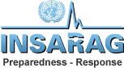 | SAFETY AND SECURITY
LEMA guidance: |  | UN advice:

