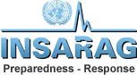 | HUMANITARIAN IMPACT
Health:
Shelter:
Food and nutrition:
Water, sanitation and hygiene:
Logistics:

