 |  | REPORTING SCHEDULE
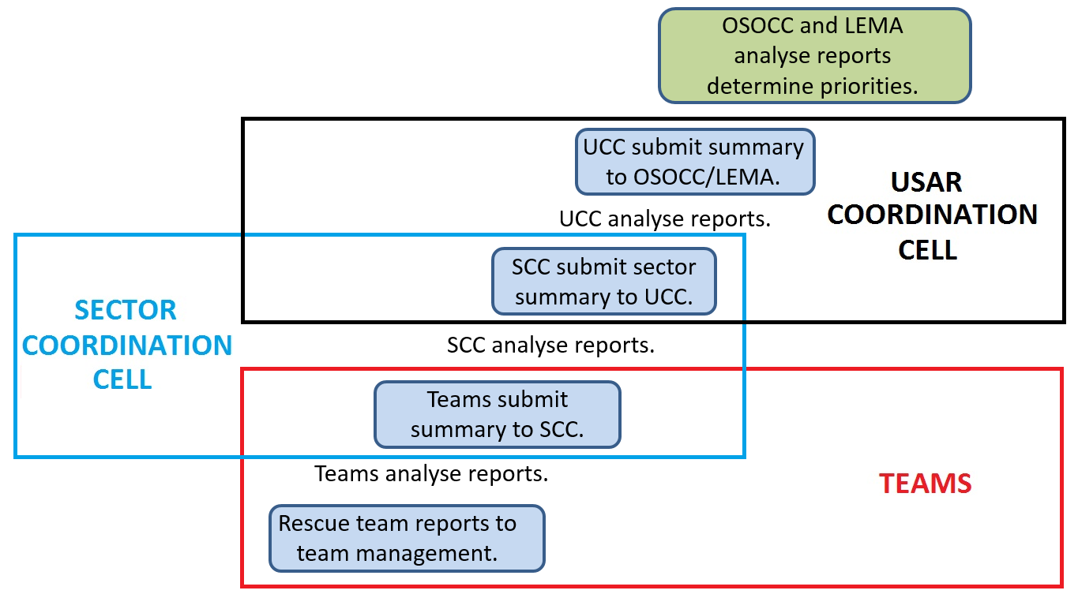 |  |  |  |  | Reports should inform coordination cells and OSOCC of operations, issues and milestones.  Summary forms should be used where possible to avoid overwhelming coordination cells.
Report from: |  |  | Team members | Teams |  | SCC | UCC
Report to: |  |  | Team managers | SCC |  | UCC | OSOCC/LEMA
By: | Date:
 | Time:
 | Method:

