 |  | BRIEFING SCHEDULE
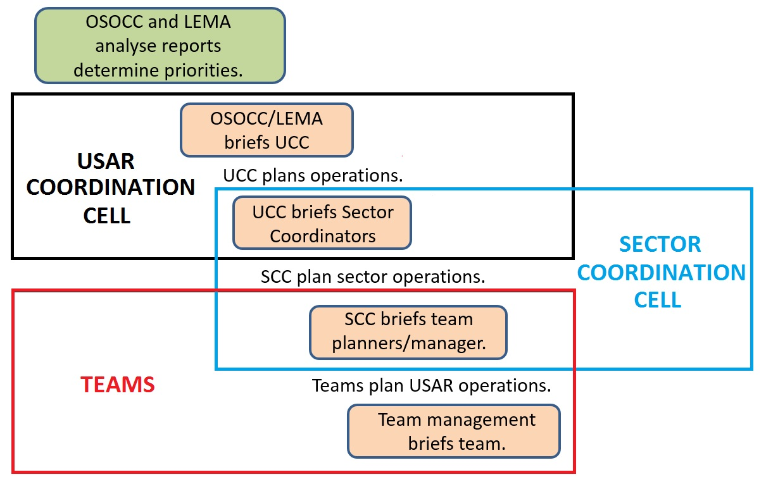 |  |  |  |  | Briefings occur to inform coordination cells and teams of:  - Operational priorities  - Safety and security issues  - Other important information
Brief from: |  |  | OSOCC/LEMA | UCC |  | SCC
Brief to: |  |  | UCC | SCC |  | Teams
By: | Date:
 | Time:
 | Method:

