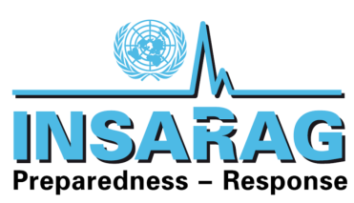

TO: Rudi Muller
ERSB- INSARAG Secretariat

FROM: Dewey Perks
INSARAG TWG Chair

SUBJECT: TWG Meeting June 2019- Minutes

DATE: 20 – 25th June 2019

Following the direction of the INSARAG Steering Group, its Training Working Group (TWG), augmented and enhanced by others, met in Muscat, Oman from June 20th to 25th 2019. Participants included the TWG, Information Management Working Group (IMWG), Team Leader and Host Country Representatives.
TWG
- Dewey Perks – Chair (United States)
- Jacob Bolwinkel (Denmark)
- Tsukasa Katsube (Japan)
- Kira Chebakova (Russia)
- Graeme Hall (Australia)
IMWG
- Rob Norman (United Kingdom)
- Team Leader/GRG
- Paul Burns (New Zealand) Representative of INSARAG Team Leaders / Guideline Review Group
- Arjan Stam (Netherlands) Remote via email
- INSARAG
- Martijn Viersma (OCHA) INSARAG Secretariat
- Mentor Relationship
- Terje Skavdal (Consultant)
- Trevor Glass (Consultant)
- Host Country
- Mohammed
- Faisal

Welcoming remarks were made by Martijn Viersma and Dewey Perks explaining the ground rules for the meeting and welcoming all participants on behalf of Manuel Bessler, INSARAG Global Chair.

Initial discussions regarding;
- Update and overview of the Guidelines Review Group (GRG) was given by Paul Burns. The GRG are working well to collate changes and update the current content, with the aim of presenting the revisions at the INSARAG Team Leaders Meeting in October.

Open Issue: Discussion occurred regarding who has the ultimate ownership of the revisions to the Guidelines, and ensuring that consensus on what was being proposed, has been reached by all involved.

Further consideration has been given to the amount of information that is being taken out of the Guidelines documents and placed into annexes, ensuring that sufficient content remains in the manuals.

Open Issue: It is unclear to the participants of this meeting, what the status of the Light Working Group will be with regards to production and maintenance of content such as the Light Team Classification checklist.

- The participants also expressed confusion between information that the Working Groups are circulating, and information that is being posted on INSARAG.org. An example of this is the current Checklist; Working Groups have recommended that colours will no longer be used, and that the Light Teams will have a separate Checklist.
- It has also been suggested that there will be separate checklists for Classifications, and Reclassifications.
- The current Checklist posted on INSARAG.org, includes Light, Medium, and Heavy teams, and includes colours on the Checklist. There is no checklist posted for the National Accreditation Process.

The Table below highlights the current status and announced owner of the relevant Checklists, where known. It is important that the Secretariat clarify this information as soon as possible so it can be circulated for review prior to the USAR Team Leaders Meeting in October.
Checklist Type | OWNER | Current Version | Version in Development
Medium & Heavy IEC | TWG | Feb 2019 on VO | 2019V1 From Oman
Medium and Heavy IER | TWG | Feb 2019 on VO | 2019V1 From Oman
Light IEC | ? | Feb 2019 on VO with Heavy & Medium IEC/R | Separate version being produced?
Light IER | ? | Light IER
NAP -Classification | ?
NAP -Reclassification | ?

- Participants received an update on the UC Training of Trainers course that was conducted in New Zealand in May 2019, with reference being made to the revised timetable for the course. Key Outcomes were the revision of contents, specifically in relation to the Data Collection Tool, and the program agenda/course schedule of the course.

It was reinforced that there is still not an accurate accounting of UC Trainers, which continues to create problems for regions and/or organizations planning to schedule a course. A direct example of this conflict/confusion resulted in the postponement of an INSARAG Steering Group (ISG) endorsed UC Training of Trainers (ToT) course in Russia for the AEME Region.

The TWG continue to be frustrated by the fact that there does not appear to be an accurate record of UC trained staff, or international trainers that can be utilised in the delivery of courses. The TWG also notes that even after numerous inquiries to the INSARAG Secretariat, there is still no handover process for the course content or preparation for host’s wishing to deliver the UC course that ensures quality control.

Reference was made to Meeting Minutes from Berlin in December 2018, where these points were raised during a telephone conference with Jesper Lund and Winston Chang;
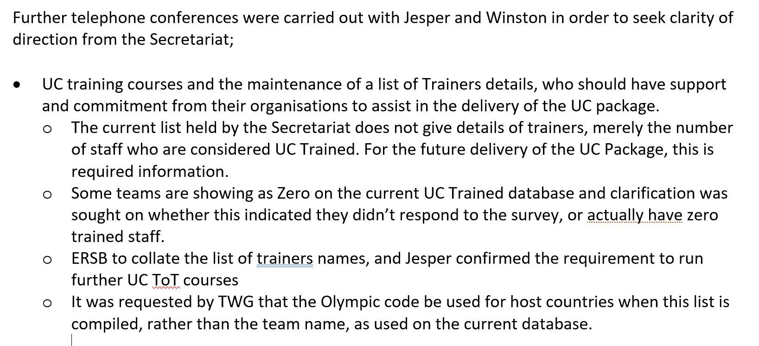
The workshop’s Secretariat Representative offered to take the issue back to the Secretariat, and provide an update. The TWG still awaits this update.

The process for maintenance and distribution of the UC course training package for those who require it needs clarification, as the course will naturally develop and change with every delivery. It also needs to be secure, so that the entire UC course content, including exam papers, and the course certificate, is not made publicly available on the INSARAG website, as has occurred previously resulting in a quality control issue.

Discussion returned to the ISG endorsed AEME course that needed to be postponed. It was noted that the ISG had requested two ToT courses be held within the AEME region this year, and if this is no longer going to be possible, then notification needs to be given to ISG.
NOTE: During the meeting, this issue was resolved. One AEME UC course will be hosted by Russia. Details will be provided in the near future.

- The process for assigning Classifiers, ensuring that quality is maintained. Discussion pointed out numerous examples of problems with how the IEC and IER system is being staffed. The TWG has requested an audit of all rostered classifiers in the system, which has not been allowed by the Secretariat. Documented instances of unqualified classifiers are increasing, which is calling the integrity of the Classification System into question. This is coupled by the Secretariat’s action of naming unsanctioned Observers as “classifiers in training”.
. This practise is not acceptable and should be discontinued as a priority.

It was again highlighted that there are Terms of Reference and criteria within the Guidelines for these roles, but frequently they are not followed.
It was also stated that last minute replacements for Classifiers, in an area where these replacements do not have the appropriate knowledge and experience. This example was for a Search Classifier that was not a Search Team Manager for his home team and had zero experience working in the Search function.

Again, it was highlighted that the TWG has raised this critical quality control issue previously with regards to the requirements and experience of the Classification team, which has been ignored by the Secretariat. It was reiterated that the ‘Process’ is well established, and is of a very high quality, the issues arise from the lack of enforcement by the Secretariat relating to the process, which is not being followed.

Open Issue: Feedback is required from Team Leaders regarding Classification Team members to highlight areas which may require further training or development.

The INSARAG Secretariat representative position within Classifications, has been delegated to Regional Chairs previously. This is not recommended as this role is critical to the classification process, particularly when the Classification Team themselves has not been quality assured, or does not meet the documented standards.

In most instances, Regional Chairs are a temporary appointment, are not an operational USAR provider, and therefore do not have the required qualifications or experience (USAR and INSARAG) to mediate discussions, if required.

TWG recommends that the Classifier Team Leaders / Mentors Refresher is re-instituted. The Refresher would be held one day immediately prior to the USAR Team Leader meeting to receive updates from previous Classifications, latest developments and requirements for the upcoming year.

It is acknowledged that this will not be possible in 20-19 as the meeting schedule has already been established, however it should commence in 2020 and become a standing arrangement.

- Discussion around delivery dates for the Team Leader / Mentor course. Delivery of the course in February allows the revised Guidelines documents to be referenced, as they will be endorsed (hopefully) at INSARAG Steering Group in February. This was agreed by TWG, and the course hosts in Oman.
Day Two – 21st June

- The day commenced with a site visit to the training ground, and a review of the facilities in preparation of the revised course delivery. The group determined that the Omani training site is more than adequate for training its USAR team, and will meet the needs for the TLM Course.
When back in plenary, Jacob provided an overview of the Team Leaders / Mentors training courses carried out in 2012 and 2014. The attendance of the Secretariat during the course was highlighted as significant, to ensure that its expectations during Classifications are reinforced with prospective TLs and Mentors.

- Discussions regarding the planning and preparations for Classifications highlighted some areas for further development, including the establishment of a strong internal Exercise Planning team for the activity. This will allow the participating team to set the direction of the exercise based on their decision making, rather than a strict timeline where every event is carefully scripted and sequenced, thereby hinders the team from demonstrating its operational and tactical planning and decision-making.

Exercises such as the EU Modex, or where bilateral arrangements are in place, which includes actions where a scenario is prepared for attending teams by an outside organisation, do not absolve the attending team of their requirements in preparing for a Classification exercise as documented within the Guidelines. In all cases, the USAR Team being classified is required to ensure it has its own EXCON involved in the design, planning and running of the exercise. The responsibility of the IEC/R remains with the team being classified; it cannot be outsourced.

- Revisions and updates were made to the Team Leaders, Mentors and Secretariat Representative Terms of Reference.

Day Three – 22nd June

- Initial discussion regarding the number of Team Leaders, Mentors and Secretariat Representative courses that will be required for 2020 was started. The TWG determined by snap analysis of information received from the Secretariat that there is sufficient need for two courses, and one refresher in 2020. The refresher will be for those people who have attended one of the previous courses, remain active in the system, and need key updates.
- A list of Classification Team Leader and Deputy allocations for 2020 was reviewed with regards to potential attendees for the February 2020 course. The list is not yet fully confirmed, and would need to be supplemented with Mentors and Secretariat representatives.
Open Issue: The first course offering will be in Oman in February 2020, the second in June in The Netherlands, with the Refresher being held in Poland in October.

- Review and discussion of the course timetable and session planning for the course, with consideration to session development and delivery, and key personnel that are likely to be required. Areas identified for content development and further planning include; role players, interoperability, safety and security.

Staff Availability for February
Paul Burns | Confirmed
Kira Chebakova
Rob Norman
Jacob Bolwinkel
Terje Skavdal
Tsukasa Katsube
Graeme Hall
Dewey Perks
Trevor Glass
Secretariat Representative (TBC)
Peter Goxharaj | Potentially
Arjan Stam
John Cawcutt
John Denny
Paul Lawless
Joe Kaleda
IMWG
Medical WG
GRG

Day 4 – 23rd June
- Paul Burns (TL Rep/GRG) introduced the current draft version of Volume II Manual C, for substantive review and revision in plenary. Further revisions and additions were made throughout the document, with links to a number of other workstreams identified.

Day 5 – 24th June
- The Group worked intensively on revisions to the IEC – IER Checklists, making numerous revisions and adding clarifications. The TWG has forwarded these to the GRG for review:
  - INSARAG IEC Checklist – Medium & Heavy
  - INSARAG IER Checklist – Medium & Heavy

Day 6 – 25th June

- Review and agreement of the new structure of the UC Training Course, as delivered in New Zealand.
There is currently no accurate information regarding the details of specific team members who have attended the UC Course, are available as UC Trainers in their respective countries, or can be made available as UC Course Facilitation staff.
The TWG recommends that the Secretariat repoll the member states to determine:
Number of people trained
number of people trained as trainers
where the training was held
name of the lead instructor
number of course taught --
their team
their region
global

- Tsukasa facilitated discussion on the ‘Exercise Design Handbook’ which will be used for IEC/R classification, and team annual exercises. Suggestions for inclusion, and the location of the exercise handbook as an Annex within Manual C were agreed.

ACTION | Responsible | Reason / Outcome | Deadline
Develop a Guidance Note on access, and storage system for the UCC training package | Graeme and Kira | To address updates and control of content through INSARAG.org. Courses have been run in China, New Zealand, USA, and soon in Russia…once Russia course is complete, a final package will be sent to the Secretariat | 15 Nov
UC Trainers Records of personnel and quality control | Rob, Tsukasa,  Graeme, Kira | Options to get the required information on trained personnel, and available facilitators for regional course delivery | Still awaiting information from the Secretariat
Draft Exercise Design Handbook | Tsukasa, Graeme,  Peter G. | Preparation of draft version required for ahead of Team Leaders meeting for review | Sept 30th – draft complete; still work in progress
Addition of ‘Unique Patient Identifier’ from Patient Treatment form, onto Victim Extrication Form | Rob | To ensure a consistent chain of care, and recording of casualties from the point of rescue to definitive medical care.
Production of EXCON training course for ERE | Dewey | Courses have been delivered in the Americas region, DP to look at standardising these, and sharing more widely. | Check with Jose Maria Garcia
Rationalisation of Manual C and modification of Annex A | Dewey and Paul | To facilitate frequent review and update of the Checklist outside of Guidelines Review.  Ongoing
Review and revision of UC Manual | Rob and Kira | To update considering IM updates.  Ongoing
Proposal for publishing Best Practice on INSARAG.Org | Confirm with GRG | To ensure sharing of best practice as widely as possible. Updates a TL meetings? Best Practice section on current Checklist.  Ongoing

- The INSARAG Calendar was reviewed with regards to the number of meetings and exercises that would require the attendance of TWG members, or where the work of the group may be shared with the wider INSARAG network, this was subsequently used to populate the 2019/20 TWG workplan

TWG 2019/20:  Work plan | Development of updated TL/M course | Development Exercise Design Handbook | Review Manual C content, including ToR, IEC/R checklist and Annexes
AP Regional Meeting, (Australia)  15-16 August 2019 | Present “TWG updates – Regional meeting” update ppt
Team Leaders and Working Groups Meeting, Chile.  October 6-11 | Finalise course contents and program.  Commence scoping for participants. | Review of final draft. | Finalise recommended changes to IEC and IER checklists and Manual C.  Hand over Manual C changes to GRG.  Complete review of all TL-M Course materials.
 | Finalise ppt x 2 (“Team Leaders meeting” and “Regional meetings”)
Regional Meeting:  AEME (Italy)  24 – 25 October 2019 | Present “TWG updates – Regional meeting” update ppt  AP: Graeme Hall  AEME: ??  Americas: Dewey Perks
Regional Meeting:  America’s (Argentina)  6-8 November 2019 | Present “TWG updates – Regional meeting” update ppt
ISG Meeting: Geneva  3-7 Feb 2020 | Present 2019 accomplishments and develop 2020 work plan
Workshop delivery:  Muscat, Oman  8-16 Feb 2020 | Deliver TLM workshop
Second Team Leader, Mentor course planned for June 2020 Netherlands | TBC | TBC | TBC
Team Leader, mentor Refresher planned for 5th to 9th October 2020 in Poland | TBC | TBC | TBC

TWG Work Plan in 2019:
- TWG will hold its final meeting of 2019 back-to-back with the USAR Team Leaders Meeting in October in Chile. TWG members may be required to attend each Regional Meeting of their respective region to represent TWG.

Acknowledgement:

The meeting was hosted by the Sultanate of Oman, Royal Oman Police (ROP), Public Authority for Civil Defense and Ambulance (PACDA), in Muscat, Oman. The meeting would not have been possible without the excellent support and generous hospitality of PACDA. The TWG would like to specifically express its thanks and appreciation to MAJ GEN Abdullah Al Harthy, COL Mubarak Al Araimi, MAJ Mohammed Al Mahmoodi, LT Faisel Al Dhuhli and their support staff.

The TWG would also like to express its appreciation to all of the participants and their respective sponsoring organisation for their valuable contributions and support.

