Annex B26: USAR Team Marking System and Signalling
- Team Function Identification
- Response team identity (country and team name) by uniform, patch, etc.
- Personnel – the following positions must be colour-coded and labelled in English plain text (vests, arm bands, helmet colour, etc.)
  - Management position(s) – white
  - Medical position(s) – red cross/crescent
  - Safety/security position(s) – orange
- Vehicles must be marked with team name (flag, magnetic sign, etc.)
- General Area Marking
- Orange spray paint is to be used for all markings.
- Assigned area or work sites are to be identified individually.
  - Address or physical location.
  - Landmark or code name (e.g. sugar factory building 1).
  - Mapping coordinates or GPS.
  - If no maps are available, sketch maps are to be produced and submitted to the UCC.
  - When producing maps, primary geographical identification should be the existing street name and building number, when possible. If this is not possible, landmarks should be used as reference and should be used universally by all actors.
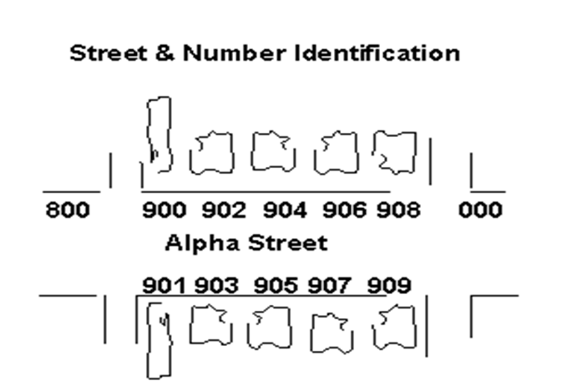
- Structure Orientation
- Structure orientation includes both an exterior and interior identification:
  - Exterior Identification: The street address side (FRONT) of the structure shall be defined as “1”. Other sides of the structure shall be assigned numerically in a clockwise manner from “1” (see graphic below).
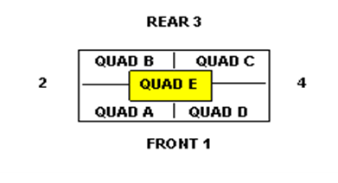
- Interior Identification:
  - The interior of the structure will be divided into QUADRANTS. The quadrants shall be identified alphabetically in a clockwise manner starting at the corner where Side 1 (FRONT) and 2 meet. Quadrant E (central lobby, elevators, staircases, etc.) applies to buildings with multiple storeys. (See graphic above).
- Worksite Markings
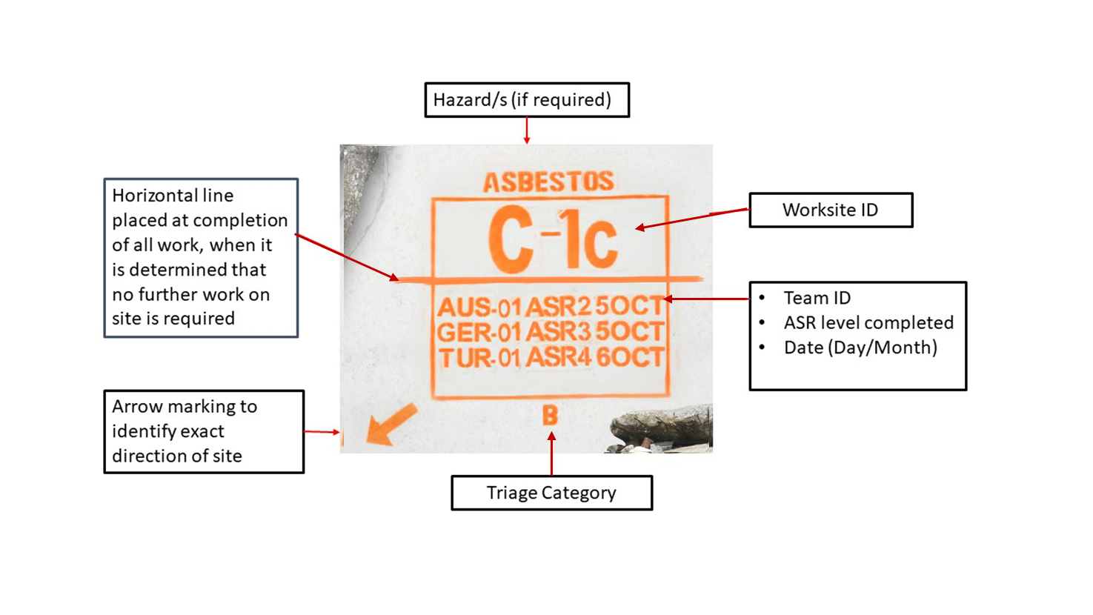
Victim Marking:
Victim marking is used to identify potential or known casualty (Live or Dead) locations that are not obvious to rescuers, e.g. below debris/entombed.
Method
The following method should be used when applying victim marking:
- When teams (e.g. Search teams) are not remaining on-site to immediately commence operations.
- At incidents involving multiple casualties or where any confusion on exact location from search operations is possible.
- Markings are done as close as physically possible to the actual surface point identified as the location of the casualty.
- Material used can be spray paint, builders crayon, stickers, waterproof card etc. as determined by the team.
- The size should approximately 50 cm.
- The colour should be highly visible and contrasting to the background.
- Not intended for use when rescue operations are completed.
- Not to be applied to the front of a structure with the Worksite ID unless that is where the casualties are located.
Progressive Examples
Description | Example | Practical Examples
Large “V” applied to location of all potential victims – live or deceased. |  | 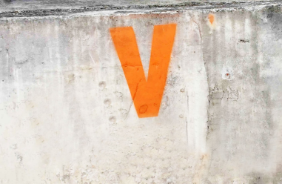
Optional arrow from “V” to clarify location if required. |  | 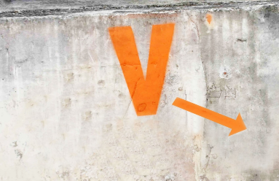
Under the “V” either:  An “L” indicating confirmed live victim, followed by a number (e.g. “2”) indicating the number of live victims at that location – “L-2,” “L-3” etc. and/or  A “D” indicating confirmed deceased victim, followed by a number (e.g. “3”) indicating the number of deceased victims at that location – “D-3”, “D-4” etc. | 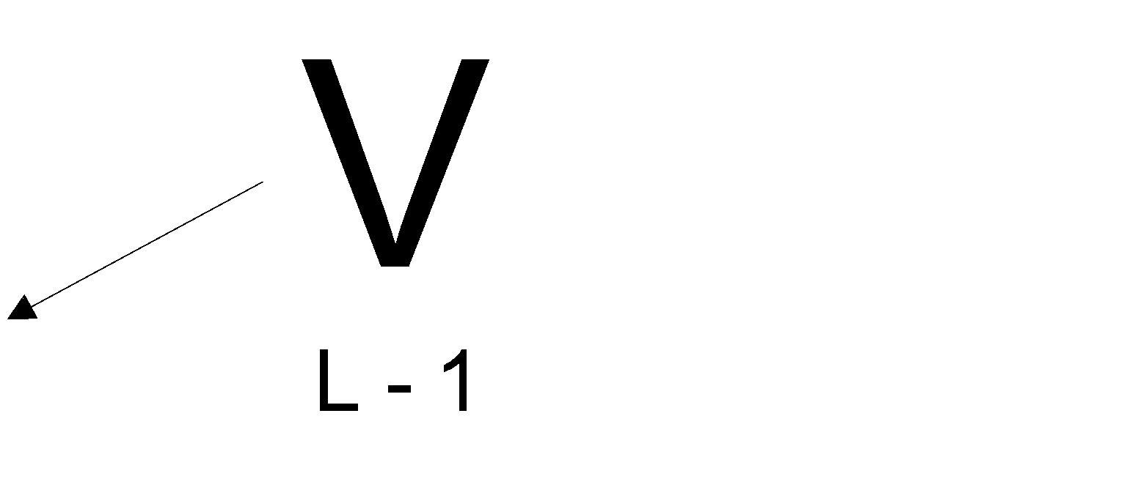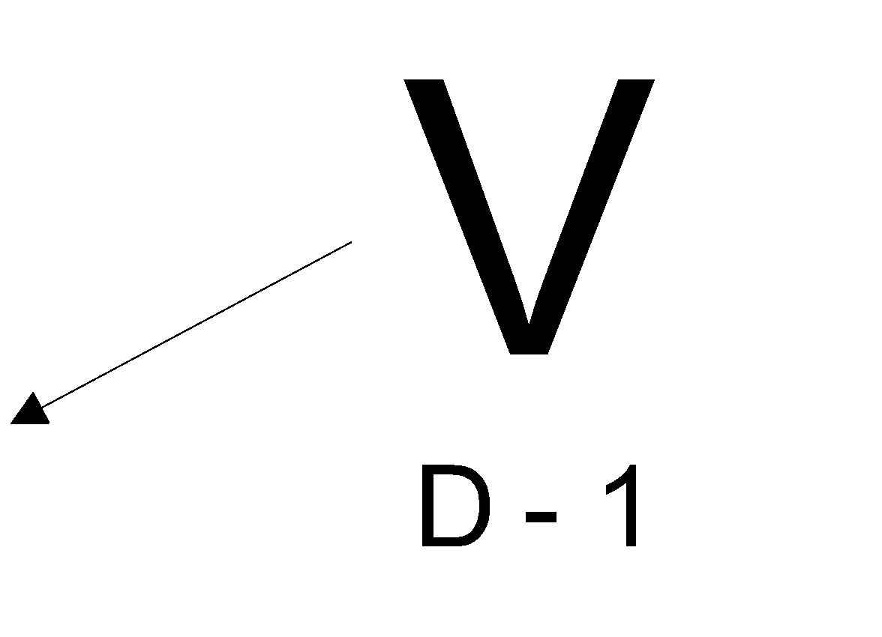 | 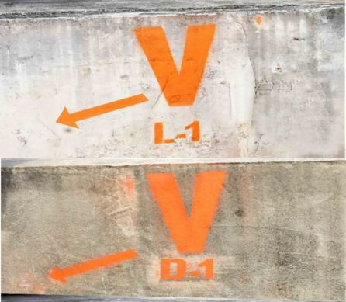
On removal of any casualty the relevant marking is crossed out and updated (if required) below; e.g. “L-2” may be crossed out and an “L-1” applied indicating only one Live victim remaining. | 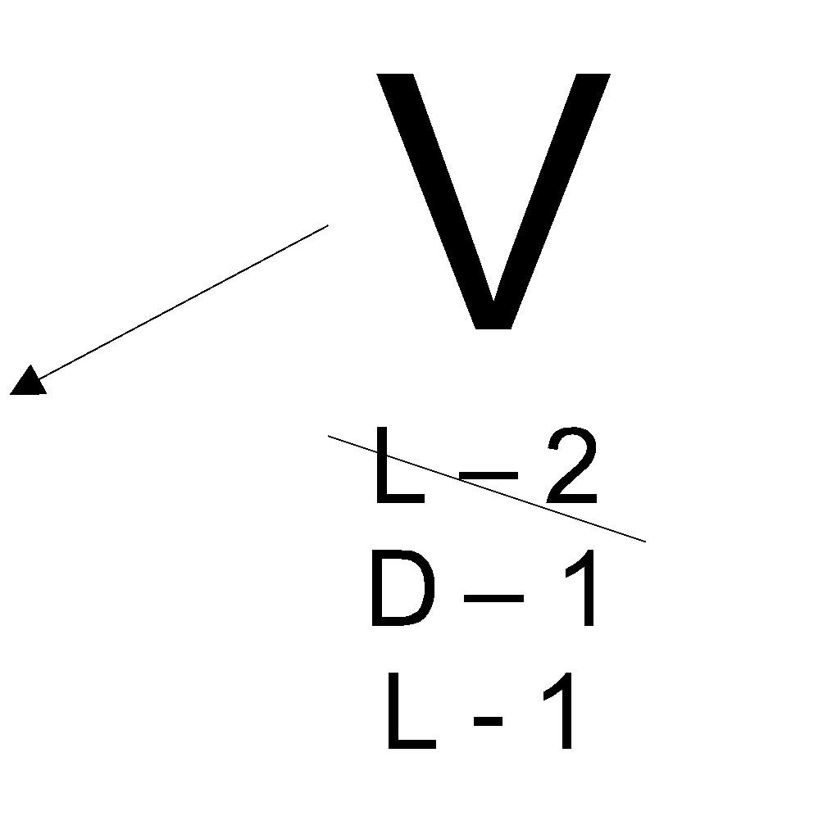 | 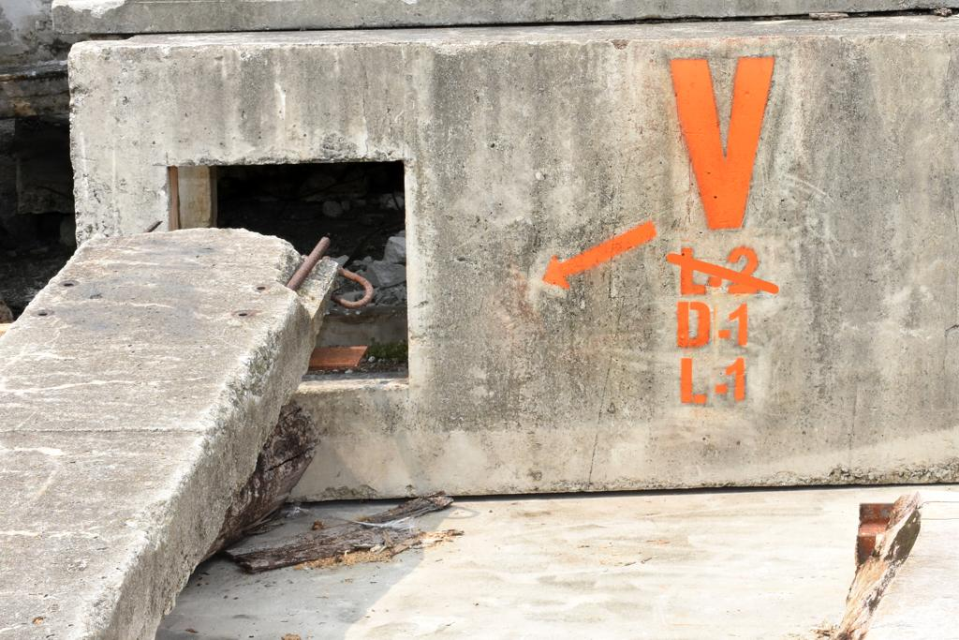
When all ‘“L” and/or “D” markings are crossed out, all known victims have been removed. | 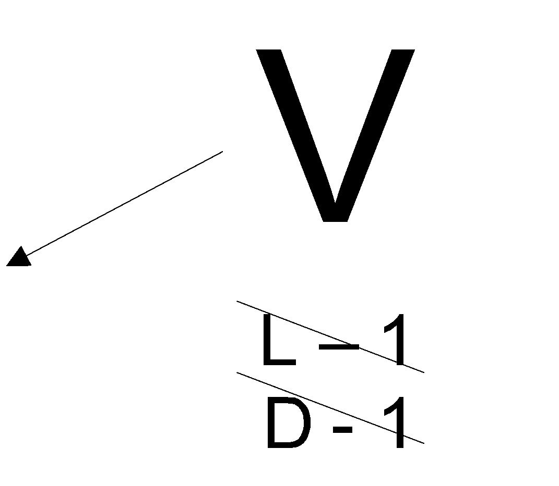

Rapid Clearance Marking System (RCM)
The Worksite ID system is only used at potential live rescue sites with other sites, where no rescues are possible, or required, not normally being marked. This allows teams to move faster, maximise life-saving opportunities and simplifies coordination. However, there are situations where it is beneficial to have a marking that can be left at sites where teams have established there are no live victims or ’deceased’ only. Leaving a recognised ‘clear’ marking will prevent duplication and have other advantages. When it is decided this level of coordination and marking is necessary the Rapid Clearance Marking (RCM) system can be used. The decision to use the system can be at the discretion of the USAR Team or be a requirement set by the LEMA/OSOCC/UC.
Method
The process for applying RCM is as follows:
- A decision has to be made, by the team or by the LEMA/OSOCC to implement this level of marking.
- RCM can only be used when sites can be fully searched quickly or there is strong evidence confirming no live rescues are possible.
- Two RCM marking options are available, they are: Clear and Deceased Only.
Clear:
Equivalent to ASR Level 5 search completion – indicating that the area/structure is clear of all live and deceased casualties.
Deceased Only:  Indicates same level of comprehensive search has been completed but only deceased casualties remain in-situ.  Note: When deceased are removed, apply “Clear” RCM adjacent to original mark. | D

Can be applied to structures that are able to be searched rapidly or where information confirms there are no live victims or only deceased remain.
Can be applied to Non-Structural areas – cars/objects/outbuildings/debris piles etc, that have been searched to standards indicated above.
Applied in the most visible/logical position on the object/area to provide the greatest visual impact.
Diamond shape with a large ‘C’ inside for Clear, or with a large ‘D’ inside for Deceased Only. Immediately below, the following is applied:
- Team ID: _ _ _-_ _ e.g. AUS-1
- Date of Search: _ _/ _ _ _ e.g. 19/Oct
- Material to be used can be spray paint, builders crayon, stickers, waterproof card etc at the discretion of the teams
- Size: approximately 20 cm x 20 cm
- Colour: bright, contrasting colour to background.
- INSARAG Signalling
- Effective emergency signalling is essential for safe operation at a disaster site.
- All USAR Team members should be briefed regarding emergency signals.
- Emergency signals should be universal for all USAR Teams.
- Signals must be clear and concise.
- Team members are required to immediately respond to all emergency signals.
- Air horns or other appropriate hailing devices should be used to sound the appropriate signals as follows:
Evacuate
Above: Evacuate: three short signals, one second each – repeatedly until site is cleared.

Cease Operations – Quiet
Above: Cease Operations - Quiet: one long signal, three seconds long.

Resume Operations
Above: Resume Operations: one long signal + one short signal.

