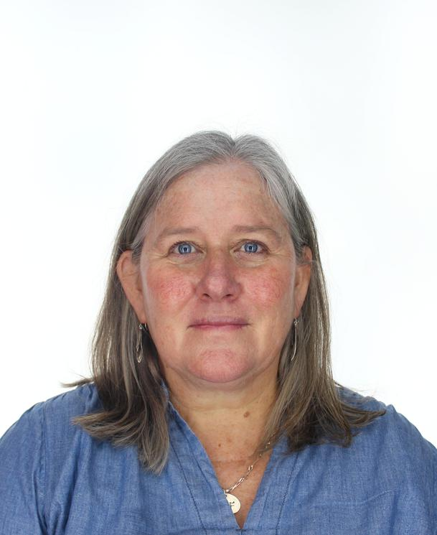
Sarah Muscroft, a British national was appointed as Coordination Division’s Chief of the Response Support Branch (D1) on 20 September. Sarah brings 30 years of humanitarian and development experience in operations and policy work on protection, transition, resilience, disaster risk management and the triple nexus in field operations and at Headquarters. Sarah has worked with OCHA for 22 years, gaining experience across different operations ranging from protracted complex emergencies, slow-onset crises, and quick on-set disasters. She has served in management roles as either Deputy or Head of Office in five country operations: Sierra Leone (2002-2004), Ethiopia (2008), Haiti (2010), Jordan (2015-2018) and oPt (2019-2022). While based at Headquarters with the Policy Branch and the Coordination Division, Sarah worked on range of policy issues from the protection of civilians to transition and resilience working in collaboration with UN and IASC partners. Prior to joining OCHA, Sarah spent a decade working with NGOs in field and headquarters including Concern, Save the Children, and the British Red Cross. Sarah began her professional career in the north of Ghana working on an education program with the Government. Sarah holds a Master of Philosophy in Anthropology and Development from the University of Cambridge.

